|  |  |  |  |  |
| --- | --- | --- | --- | --- |
| |  | | --- | |  | |  | |  | |  | |
| Process Book  Wages and Flows |
| Samik Adihkari  Nicholas Stellitano  CS 171  May 06th 2015 |

Table of Contents

Overview and Motivation 1

Standard Metrics 1

The importance of wages 1

Related Work 1

Previous Literature 1

Questions 2

How does migration compare to other bilateral indicators? 2

Data 1

Data Source: 1

Data Processing: 1

Exploratory Data Analysis 2

Overall Development: 2

Various Visualizations: 2

Design Evolution 1

Migration as a Node: 1

Migration as a Edge: 1

Implementation 2

Wage Comparison: 2

Migration Flows: 2

Evaluation 3

Conclusion: 3

Functionality and Future Improvements: 3

# Overview and Motivation

### Standard Metrics

Migration is an actively studied phenomenon within the international development community. Typically, measurement is quite difficult. Census data within wealthy countries (OECD countries) is challenging to come by and nearly impossible in developing countries with very low government capacity. When the numbers are available migration flows, stocks (by gender and by education level), along with remittance is measured. The general theory is that migration allows individuals to earn money to send back to their home country, which can then help improve the lives of the migrant’s family members. Other metrics and considerations that are taken into account are regional flows, laws that dictate when and who can migrate into various countries, along with migration patterns.

### The importance of wages

One recent theory proposed is that OECD countries actually have an outsized impact on developing countries through migration policies. Through the inherent wage differential, not only will migrants benefit from higher pay but the country of origin can also benefit as well. If migrants are still considered part of the country of origin then the percentage of the population that is located in other countries can still have a positive (if not outsized) affect on the economy. By analyzing a selected grouping of Non OECD countries and their relationship with OECD countries we hope to be able to show the overall affect migration can have over local economies.

# Related Work

### Previous Literature

One recent theory proposed is that OECD countries actually have an outsized impact on developing

# Questions

### How does migration compare to other bilateral indicators?

Globalization is on the rise in the 21st century and labor mobility is a big part of the process. We are interested in comparing the economic benefits people gain when moving from a “developing” to a “developed” country.

In particular, we want to compare the average wages that people gain from moving into a developed country with other bilateral indicators such as remittances that people send back home, foreign assistance and aid that flows from developed to developing countries and so forth.

The beauty of visualizing this information is that it does not only compare the different form of assistance made available by developed countries to developing countries, but it also gives us the scale of those comparisons.

# Data

### Data Source:

There are three data sources that we are using for our visualization project:

* (Wage/Population/Aid data): World Development Indicators (<http://databank.worldbank.org/data/views/variableSelection/selectvariables.aspx?source=world-development-indicators>)
* (Migration data by education/gender): IAB brain drain data (http://www.iab.de/en/daten/iab-brain-drain-data.aspx#Sources)
* (Remittance data): World Bank (<http://econ.worldbank.org/WBSITE/EXTERNAL/EXTDEC/EXTDECPROSPECTS/0,,contentMDK:22759429~pagePK:64165401~piPK:64165026~theSitePK:476883,00.html>)
* We were also able to get wages data for a set of 33 countries (24 non-OECD and 8 OECD, by education levels, from the World Bank)

### Data Processing:

The Data processing stage involved 3 stages:

1. Adjusting Wage data to represent…
2. Compiling data for 2010 – json building etc…
3. Compiling json data for 1980 – 2010 etc…

# Exploratory Data Analysis

### Overall Development:

The first issue we ran into when developing ideas for the site was with all the available data, which data and what time frame do we utilize to tell an engaging story.

### Various Visualizations:

The first issue we ran into when developing ideas for the site was with all the available data, which data and what time frame do we utilize to tell an engaging story.

1. GeoJSON Map
2. Scatter Plot:
3. Bar chart :
4. Sankey Diagram:

# Design Evolution

### Migration as a Node:

The first

### Migration as a Edge:

The first

### Unforeseen Problems:

The first

# Implementation

### Wage Comparison:

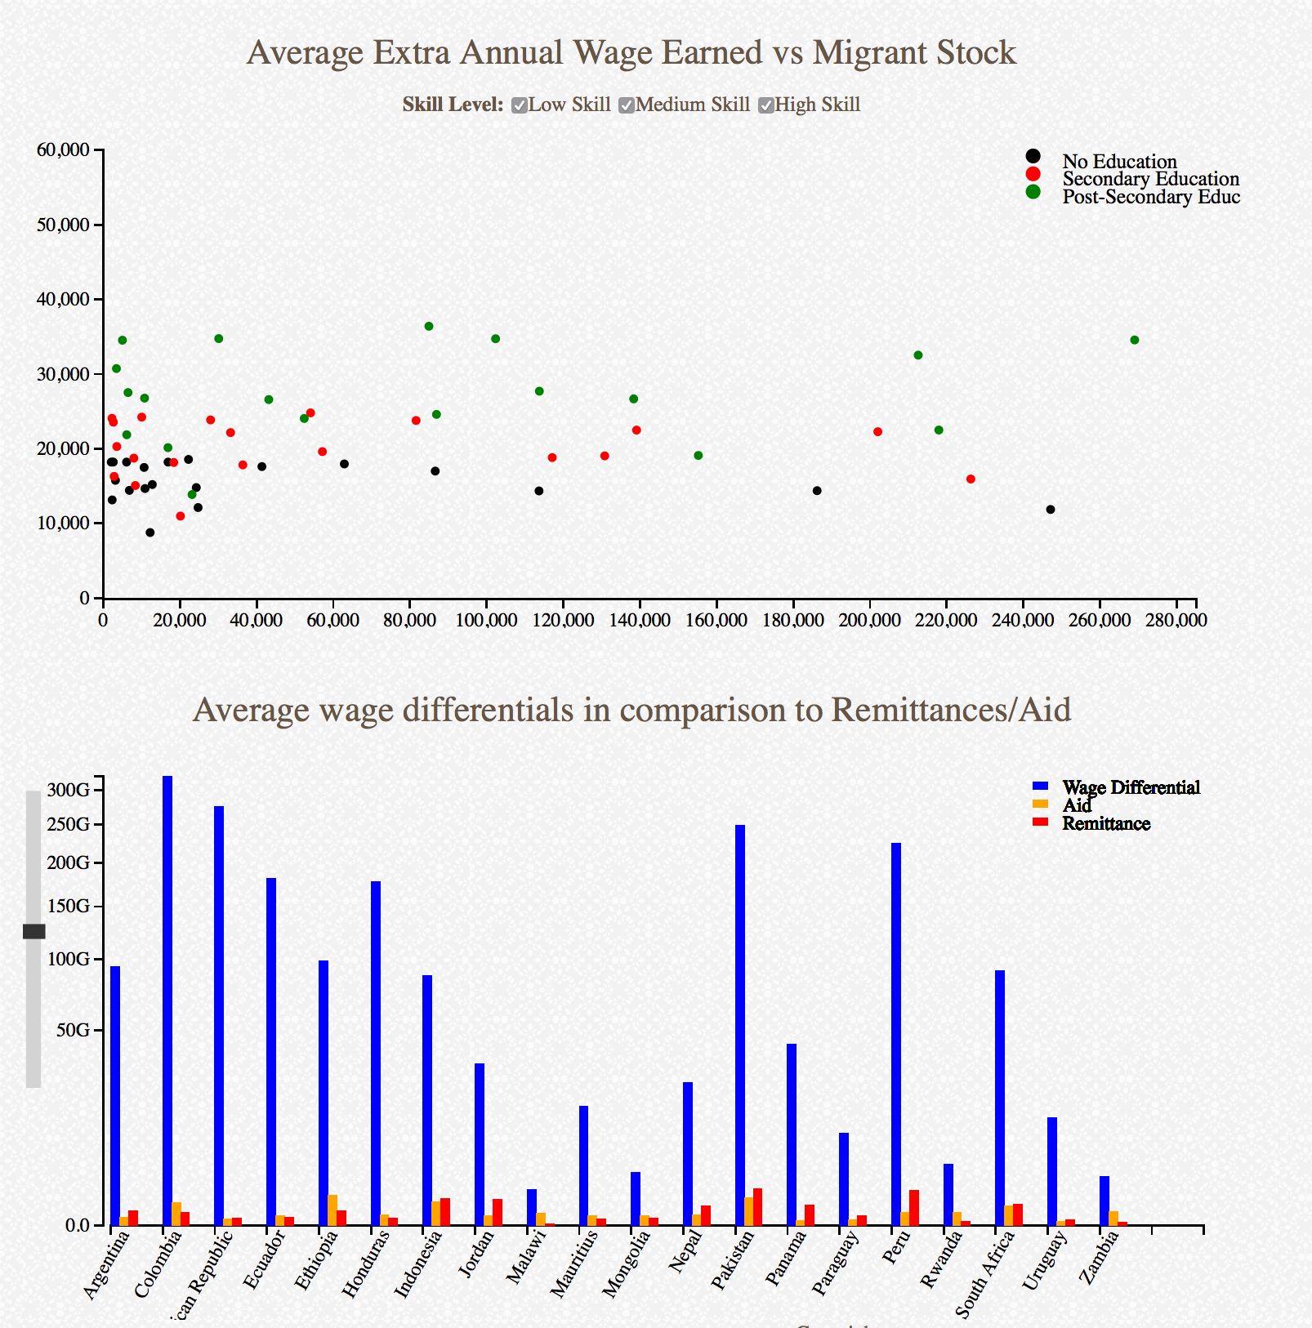The first

### 

### 

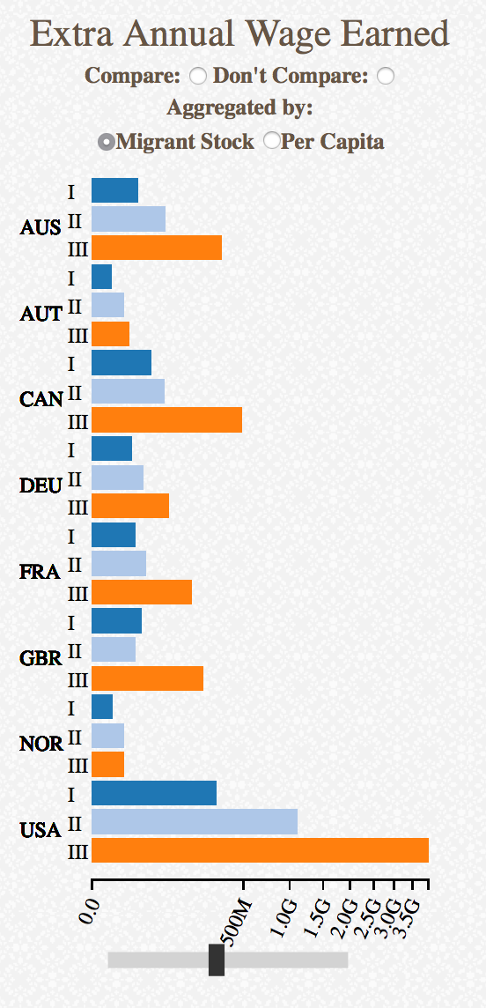

### Migration Flows:

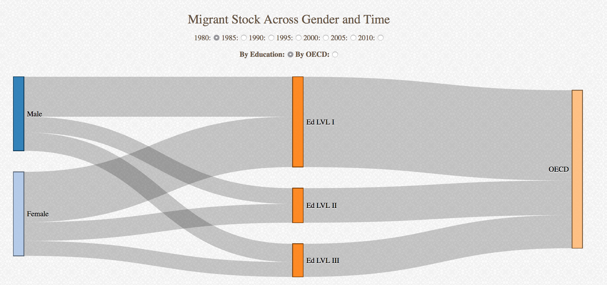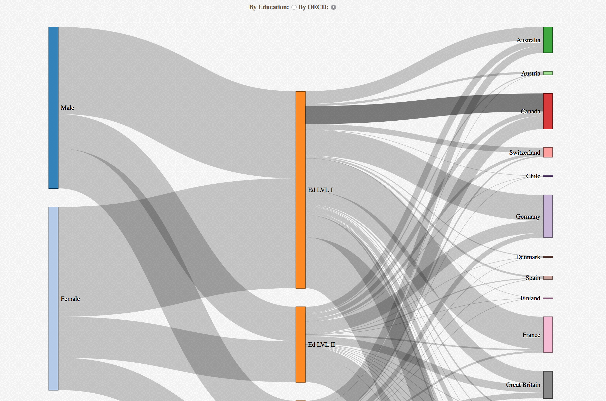The first

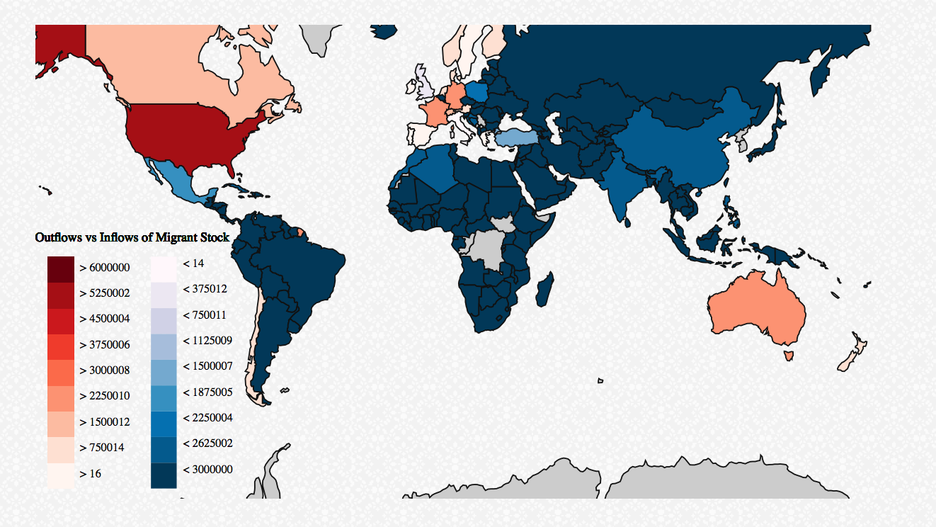

# 

# Evaluation

### Conclusion:

From our visualizations we learned how wage can….

### Functionality and Future Improvements:

Overall we are very pleased with how the website works and shows our… A few parts need to be improved upon as time continues:

1. Further distinction for MAP Colors
2. Add more data
3. PPP

Appendix

### Initial Project Proposal:

* **Background and Motivation:** As two students of the MPAID program we are very interested in the role Migration plays in International Development. One of our Program Directors is interested in visualizing the overall wage increment of migrants from Non-OECD countries to OECD countries. We hope to visually depict not only the Bilateral flows of Migration and Remittance but the overall changes in Wages by education level and gender when they move from developing countries to non developing countries. Also, showing these in comparison to more standard metrics like Aid and Trade will be beneficial.
* **Project Objectives.** What is the overall increment on wages of migrants of certain skill levels when they move from a developing country to a developed country? How does that increment compare to overall trade flows, remittances, and aid flows.
* **Data.** Our data will be collected in three forms
  + **(Wage/Population/Aid data):** World Development Indicators (<http://databank.worldbank.org/data/views/variableSelection/selectvariables.aspx?source=world-development-indicators>)
  + **(Migration data by education/gender):** IAB brain drain data (<http://www.iab.de/en/daten/iab-brain-drain-data.aspx#Sources>)
  + **(Remittance data):** World Bank (http://econ.worldbank.org/WBSITE/EXTERNAL/EXTDEC/EXTDECPROSPECTS/0,,contentMDK:22759429~pagePK:64165401~piPK:64165026~theSitePK:476883,00.html)
* **Data Processing.** We expect to construct some indicators through the aggregation of multiple data sets. We expect this to be somewhat time consuming but doable.
* **Visualization.** Our basic design incorporates two overall products (more if time permits). The idea is to start from a global perspective (product 1) and refine to smaller levels of data by selecting on various types of countries (product 2)
  + The first would be utilizing a map of the world and creating a heat map of migration related indicators. Some of the indicators that are available or could be constructed from the data included are migration flows to and from OECD countries, average wages gained by migrants by moving to a OECD country, remittances, aid flows, and trade flows. The preliminary idea is to use Radio Buttons to switch across different visualizations utilizing the concepts learnt in HW2.
  + The second product utilizes concepts seen in HW3. Along with the world map, we will have various migration related layouts, which can interact with one another through use of sliders, brushes, and point-clickers. The designated task would be quantitative in nature. By selecting either an OECD country or a Non OECD country, various graphs would change to map the top 5 selected “partner” countries along with various characteristics to include overall remittance, migrant stocks, aid, trade, and wage differential.
  + In essence, the idea is to create something similar to one of the previous projects (https://ba66f0012633a2840e66efc393df816fc324c2f4.googledrive.com/host/0B6YljmV-VTJZcElIUWlVZGIzTmM/index.html) but with focus on migration rather than aid:
* **Must-Have Features.** Product 1 (Heat Map), Product 2 (interconnected display of country data)
* **Optional Features.** Extending further, it would be cool to visualize “flows” of migrants or remittance through visual mappings and connected lines. Example: (http://www.citylab.com/tech/2013/12/facebook-using-your-profile-track-global-urban-migration-trends/7982/)
* **Project Schedule.** Our overall timeline is as follows:
  + **Week 0:**
    - Setup Github
    - Develop Workflow
    - Submit Proposal
    - Develop Project components
  + **Week 1 (6th-10th):**
    - Create small workable dataset
    - Create Index File
    - Build out Map
    - Identify Graphs to be utilized
  + **Week 2 (13th – 17th):**
    - Complete Data Set
    - Complete Heat MAP
    - Divide up objects (graphs) to be constructed
  + **Week 3 (20th – 24th):**
    - Data crunch required ratios and numbers
    - Complete Object Graphs and interconnect
    - Develop pictures of regional or group flow patterns?
  + **Week 4 (27th- 31st):** 
    - Work on Aesthetics of the website (colors, displays, etc…)
    - Loud on Github, test
  + **Week 5 (4th – 7th):** 
    - Create Video

### Initial Feedback: April 21st 2015

Design Studio Feedback

Group Partner: Michael (MIT)

Feedback 1:

We should use legends and have a really good narrative for the story we want to tell with our visualization.

Comment: Both Michael and us were working with maps. He was working with transportation data from Massachusetts. We are working with the map of the world. And he thought it was more challenging to get the attributes for all countries correct, especially given that both our teams were trying to vary the map by more than one indicator. So, I think this feedback was helpful in making the visualization more compact.

For the narrative part, Michael advised us to use texts and brief paragraphs, either accompanying the maps in the layout or having them pop up as users click different features on the map. We will take that into consideration.

Feedback 2:

Michael felt we had too many graphs in the same layout and he was struggling with the same problem.

Comment: The tradeoff here is telling a comprehensive story vs. having a compelling visual layout. We want to balance the two. We definitely do no want to cram everything together but we do want to say a coherent story given our hypothesis on migration. One optional feature we would like to have is a different layout (from our main layout), where we show animations because we have data that varies by time and we are not using it in our main feature.

Feedback 3:

Michael advised us to use pull information from different smaller json files as opposed to having one large json file.

Comment: The tradeoff here is between having several tractable json files and having one large file that could be used for multiple interactive graphs. Interactivity between several plots and the map is a must for the kind of stories we want to tell and we decided to have one large json file based on which we will create most of our layouts.

### Initial Design Studio Drawings: